COMPUTER NETWORKS

TOPIC:
SETTING UP VLANS

NAME:
MUHAMMAD TALHA
ROLL NUMBER:
241890
SECTION:
4/A

INSTRUCTOR:
SIR MUHAMMAD BILAL
LAB TASK: setting up virtual private networks using switches and cli programming
TOPOLOGY:
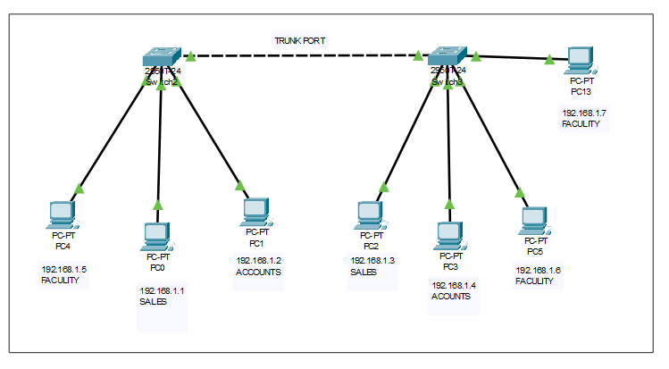
SETTING IP(CONFIGURATIONS)
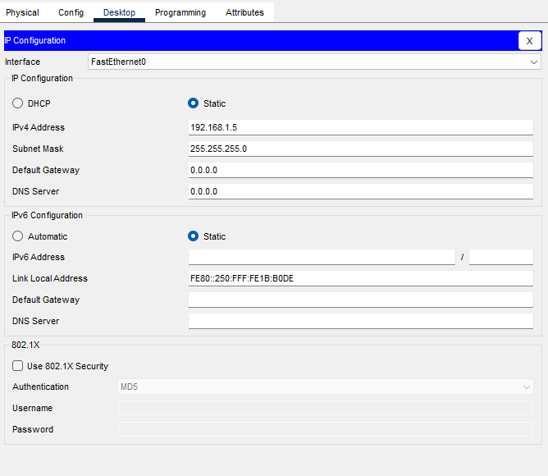
SETTING VLANS:
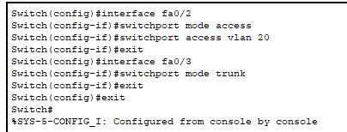
SWITCH 1 CLI:
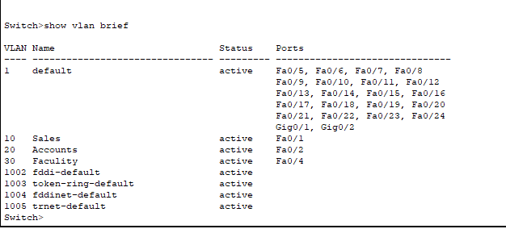
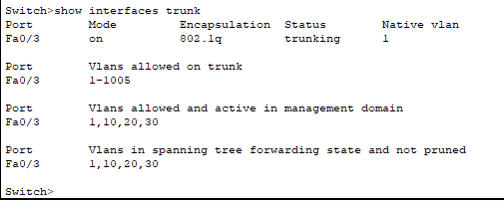

PORTS FROM SWITCH 1:
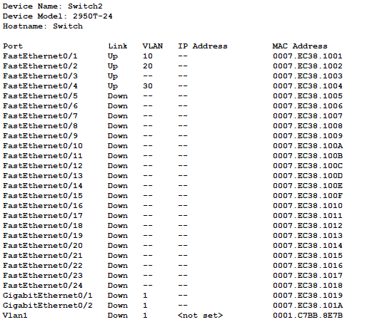
PING FROM FACULTY VLAN:
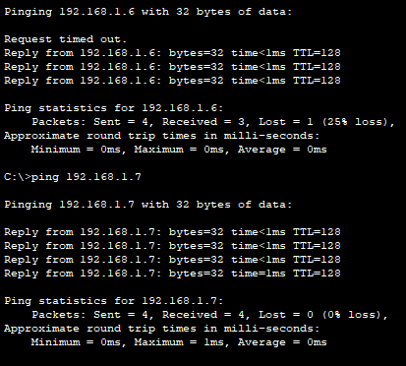
Same vlan:

Different vlan:
